



RHINO

Test Report

Version: 0.1

**Mar 16 2017**

Author: Khanh Vu

Security Classification:**Confidential**

Software Development & Business Process Services

110 Bishopsgate, London

EC2N 4AY

Tel: +44 (0)20 7333 0033

Email: [info@nashtechglobal.com](mailto:info@nashtechglobal.com)



Table of Contents

1. Execute summary 6

1.1 Overview: Project Background and Scope 6

1.2 Scope 6

2. Execution and Analysis 7

2.1 Performance Test Results and Analysis 7

2.2 Test Run 1 – Baseline Two Hour Load Test 7

2.3 Test Run 2 – Baseline Two Hour Load Test 13

2.4 Test Run 3 – Baseline Two Hour Load Test 18

2.5 Test Run 4 – Baseline Two Hour Load Test 20

2.6 Test Run 5 – Baseline Two Hour Load Test 24

2.7 Test Run 6 – Baseline Two Hour Load Test 28

2.8 Memory and CPU Utilisation Statistics for severs in 1 day during 6 load test runs 32

2.9 Analysis Summary 39

Document History

| Document Location | |
| --- | --- |
| File Name | Location |
| Rhino_Load Test Report.docx | <SVN Folder> |

| Document Version History | | | |
| --- | --- | --- | --- |
| Version | Date | Edited by | Details |
| 0.1 | Mar 16th, 2017 |  | Create Test Report |
|  |  |  |  |
|  |  |  |  |
|  |  |  |  |
|  |  |  |  |
|  |  |  |  |

Approvers

| Distribution List | | | | |
| --- | --- | --- | --- | --- |
| Name | Role | Signature | Date | Version |
|  |  |  |  |  |
|  |  |  |  |  |

Confidentiality

This document is distributed on a restricted basis, is commercial in confidence to the recipient, and may not be used for any purpose other than that associated with a NashTech project. The contents of this document may not be disclosed to any third parties without the expressed advance written authorisation of NashTech.

# Execute summary

## Overview: Project Background and Scope

Rhino is the software to help owners of small businesses easily manage their work with:

* Clients’ contacts
* Sales proposals
* Projects
* Tasks
* Invoices
* Payment
* Administrative configurations like user management, project types, expense types, system settings, system appearance, etc.

Supported sectors in this application include:

* Construction
* Professional, Scientific & Technical Services:
* Administration & Support Services

## Scope

| Groups | Functions | Percentage (%) |
| --- | --- | --- |
| Normal users | Home | 80% |
| Login |
| Add contact |
| Add sale proposal |
| Add Timesheet |
| Add Expense |
| Add reminder |
| Add note |
| Admin users | Home | 20% |
| Login |
| Add invoice for contact |
| Add invoice for Sale proposal |
| Add invoice for Empty project |
| Add invoice for Project with Task |
| Add invoice for Project with Timesheet and Expense |
| Approve Timesheet |
| Approve Expense |

# Execution and Analysis

## Performance Test Results and Analysis

We are using scripts to simulate user behaviour for up to 2500 virtual users, to measure response times of the system under various load conditions to identify the application’s breaking point, assuming that the breaking point occurs below the peak load condition.

Each load test was executed with 2500 virtual users. Each request should achieve an acceptable response time while processing.

**Performance Requirement**

* Response time for each user’s click must be less than or equal 3 seconds, except Invoice function it will be 10 seconds because this function take more time to collect data and calculating.

## Test Run 1 – Baseline Two Hour Load Test

* Duration: 1 hour, 51 minutes
* Started: Mar 16, 2017, 9:25:45 PM
* Ended: Mar 16, 2017, 11:22:36 PM

**Observations**

### Request Statistics

This report shows statistics for each request (also known as element label) in the test

|  |  |  |  |  |  |  |  |  |
| --- | --- | --- | --- | --- | --- | --- | --- | --- |
| **Element Label** | **# Samples** | **Avg. Response Time (ms)** | **90% line (ms)** | **95% line (ms)** | **99% line (ms)** | **Min Response Time (ms)** | **Max Response Time (ms)** | **Error Percentage** |
| ALL | 135112 | 165430.37 | 350271.4 | 489260.6 | 917056.9 | 0 | 2786978 | 0.95% |
| Add Invoice for Contact | 500 | 198869.24 | 338431 | 350463 | 359167 | 323 | 361317 | 0% |
| Add Invoice for Empty project (Project 01) | 264 | 576717.97 | 892927 | 1014783 | 1038335 | 22010 | 1054751 | 0% |
| Add invoice for project has Timesheet and Expense (Project 03) | 57 | 947388.7 | 938495 | 971263 | 1012735 | 521480 | 1355465 | 0% |
| Add invoice for Project with task (Project 02) | 155 | 656629.23 | 944127 | 1016319 | 1040383 | 156832 | 1061443 | 0% |
| Add Invoice for Sale Proposal | 500 | 382599.65 | 578559 | 656895 | 686079 | 417 | 706815 | 0.40% |
| Back_to_Project | 585 | 155.3 | 367 | 494 | 956 | 3 | 1933 | 0% |
| Click_Add_Contact | 3225 | 204.79 | 474.47 | 772.01 | 1963.54 | 3 | 5360 | 0% |
| Click_Add_Expense | 2197 | 67.61 | 201.02 | 352.74 | 734.53 | 1 | 1234 | 0% |
| Click_Add_Invoice | 1540 | 184.65 | 447 | 713 | 1377 | 3 | 3030 | 0% |
| Click_Add_Note | 6081 | 176.68 | 397.64 | 593.74 | 1791.23 | 3 | 6004 | 0% |
| Click_Add_Project | 811 | 140.01 | 313 | 425 | 899 | 3 | 3367 | 0% |
| Click_Add_Reminder | 5884 | 175.34 | 412.59 | 602.1 | 1573.81 | 3 | 5487 | 0% |
| Click_Add_Sale | 2874 | 52.19 | 158.95 | 267.33 | 519.14 | 1 | 1414 | 0% |
| Click_Add_Task | 217 | 134.65 | 340 | 441 | 707 | 3 | 1155 | 0% |
| Click_Add_Timesheet | 2281 | 60.17 | 169.82 | 307.45 | 611.24 | 1 | 1412 | 0.04% |
| Click_Delete_button | 327 | 145481.36 | 280319 | 284927 | 294399 | 572 | 295170 | 0% |
| Click_Edit_Task | 360 | 135.37 | 341 | 430 | 752 | 3 | 1065 | 0% |
| Click_Invoice_icon | 1553 | 279.13 | 661 | 1022 | 1879 | 1 | 3864 | 0% |
| Click_Login | 3489 | 121525.76 | 294179 | 356258.8 | 438474.8 | 45 | 538202 | 0% |
| Click_Note_icon | 6085 | 166.85 | 381.71 | 548.02 | 1610.95 | 1 | 5546 | 0% |
| Click_Reminder_icon | 5885 | 173.9 | 412.16 | 589.64 | 1579.04 | 1 | 6188 | 0% |
| Click_Save_Contact | 3216 | 132895.54 | 299190.3 | 368376.8 | 425806.5 | 81 | 574657 | 0% |
| Click_Save_Expense | 1733 | 320766.91 | 519961.3 | 562910.4 | 610911.6 | 23991 | 760735 | 21.47% |
| Click_Save_expense | 57 | 204381 | 305407 | 313343 | 314623 | 92169 | 315208 | 0% |
| Click_Save_Invoice | 1000 | 123748.17 | 197887 | 225663 | 296447 | 96 | 308931 | 0.20% |
| Click_Save_Invoice01 | 264 | 142235.86 | 216191 | 292863 | 299519 | 20244 | 310393 | 0% |
| Click_Save_Invoice02 | 155 | 159992.64 | 253055 | 294143 | 296703 | 44765 | 300298 | 0% |
| Click_Save_Invoice03 | 38 | 180646.24 | 208255 | 256767 | 309247 | 139485 | 309160 | 0% |
| Click_Save_Note | 6071 | 166725.85 | 311199.2 | 413584.2 | 489688.3 | 51 | 586785 | 0.03% |
| Click_Save_Project | 301 | 281288.44 | 405503 | 500223 | 517119 | 35281 | 520872 | 0% |
| Click_Save_Project01 | 398 | 145524.13 | 237823 | 294655 | 308991 | 215 | 311488 | 0% |
| Click_Save_Reminder | 5883 | 168071.1 | 291708.6 | 385042.8 | 469093.3 | 52 | 588061 | 0.03% |
| Click_Save_Sale | 500 | 120108.51 | 189823 | 195583 | 217727 | 70 | 225401 | 0% |
| Click_Save_SaleProposal | 2337 | 160271.68 | 294014.2 | 324882.1 | 466912.2 | 63 | 568203 | 0% |
| Click_Save_Task | 202 | 153708.1 | 234879 | 291583 | 309503 | 20845 | 310109 | 0% |
| Click_Save_Timesheet | 71 | 182921.42 | 295167 | 297727 | 304383 | 90661 | 304961 | 0% |
| Click_Save_TimeSheet | 2138 | 287459.95 | 484599.3 | 521531.9 | 564084.3 | 2198 | 634313 | 11.88% |
| Click_Tasks_button | 616 | 124.73 | 306 | 413 | 652 | 3 | 1236 | 0% |
| DEL Default Project Task 02 | 1 | 294764 | 294911 | 294911 | 294911 | 294764 | 294764 | 0% |
| DEL Empty project | 4 | 261933.25 | 292607 | 292607 | 292607 | 188357 | 292437 | 0% |
| DELETE CompanyContact | 1165 | 272673.37 | 444343.6 | 469997 | 518508.4 | 30512 | 552405 | 0% |
| DELETE Expenses | 884 | 254735.37 | 435684.1 | 462352.1 | 517522.4 | 0 | 564748 | 0.68% |
| DELETE Invoice for Contact | 35 | 186324.86 | 275967 | 284159 | 295679 | 141563 | 295563 | 0% |
| DELETE Invoice for Empty project | 18 | 198177.61 | 211199 | 238079 | 296703 | 162491 | 296687 | 0% |
| DELETE Invoice for Project 02 | 1 | 205441 | 205567 | 205567 | 205567 | 205441 | 205441 | 0% |
| DELETE Invoice for Sale | 31 | 197245.1 | 275199 | 276223 | 285695 | 143190 | 285490 | 0% |
| DELETE Note for a Sale | 2243 | 169899.87 | 262039.8 | 284862.9 | 444103.8 | 52 | 543711 | 0% |
| DELETE Note for an expense | 1042 | 223294.38 | 414520.3 | 440876.5 | 509182.3 | 23869 | 574147 | 0.19% |
| DELETE Reminder for a Sale | 2237 | 158861.77 | 248926.2 | 282047.1 | 443119 | 52 | 513968 | 0% |
| DELETE Reminder for an expense | 930 | 239405.41 | 438484.1 | 476371 | 521704.2 | 30961 | 609974 | 0.22% |
| DELETE SaleProposal | 2254 | 170248.21 | 265664 | 299856.2 | 434007.3 | 63 | 545013 | 0% |
| DELETE_Note_for_a _Contact | 2414 | 153776.52 | 284097 | 304533.8 | 485777.8 | 41 | 552109 | 0% |
| DELETE_Reminder_for_a_Contact | 2448 | 141082.92 | 241342.3 | 316793 | 458217.4 | 51 | 564869 | 0% |
| EDIT Empty Project | 16 | 466.19 | 928 | 941 | 1307 | 89 | 1307 | 0% |
| Get_CompanyContactSalesLifeCycle Id | 2874 | 155949.59 | 275252.4 | 304043 | 435209.2 | 46 | 566217 | 0% |
| Get_Expense_information | 106 | 164595.26 | 292095 | 296447 | 300287 | 44644 | 304006 | 0% |
| Get_Expense_Information | 1956 | 537141.96 | 884131.7 | 926203.3 | 982815.5 | 21635 | 1048214 | 0.10% |
| Get_Expense_Type_ID | 2129 | 277912.59 | 452537.5 | 481261.8 | 530807.4 | 115 | 582959 | 0.05% |
| Get_ExpenseTypeId | 106 | 164595.26 | 292095 | 296447 | 300287 | 44644 | 304006 | 0% |
| Get_ProjectBasicInformation | 454 | 148964.54 | 274687 | 300543 | 312319 | 276 | 318979 | 0% |
| Get_ProjectTaskInformation | 1956 | 264880.16 | 460475.9 | 489337.8 | 541943.4 | 16732 | 578499 | 0.05% |
| Get_Timesheet_information | 2261 | 792919.24 | 934282.4 | 967650.9 | 997998.6 | 397 | 1588720 | 0% |
| Get_userCostAmtId Default | 123 | 153518.94 | 272127 | 283647 | 284927 | 35241 | 289893 | 0% |
| Get_userCostCodeId Default | 138 | 151017.49 | 253951 | 284671 | 291327 | 41835 | 291721 | 0% |
| Get_UserProfiles | 2784 | 148247.73 | 385107.4 | 457320.1 | 525820.7 | 55 | 620243 | 0% |
| Login_authentication | 3390 | 135280.25 | 315004.3 | 406936.8 | 467230.2 | 60 | 564087 | 0% |
| Open_Default_Task_Detail | 361 | 136.15 | 330 | 512 | 811 | 3 | 2276 | 0% |
| SELECT Empty Project | 16 | 268975.19 | 297471 | 297983 | 307967 | 169329 | 307837 | 0% |
| Select_Default_Task | 723 | 136910.01 | 227711 | 280063 | 285695 | 86 | 287165 | 0% |
| Select_Project02 | 185 | 163887.31 | 292863 | 298495 | 308991 | 36239 | 309404 | 0% |
| Select_Project03 | 43 | 171252.93 | 211071 | 279295 | 297215 | 108980 | 297044 | 0% |
| Transaction Contact | 2414 | 660382.62 | 985474.3 | 1015806 | 1036413 | 435 | 2041737 | 0% |
| Transaction Expense | 1256 | 1451491.46 | 994937.3 | 1026603 | 1042518 | 192569 | 2786978 | 30.10% |
| Transaction Sale Proposal | 2229 | 1117943.96 | 907259.6 | 962419.8 | 1033847 | 650 | 2581300 | 0% |
| Transaction Timesheet | 2138 | 1112055.58 | 1028735 | 1039485 | 1047294 | 2699 | 2101096 | 11.93% |
| Visit_Contact_page | 3225 | 6322.23 | 21392.5 | 52306.62 | 59579.24 | 88 | 66272 | 0% |
| Visit_Expense_page | 2198 | 2461.97 | 2673.93 | 4962.98 | 48623.42 | 90 | 65051 | 0% |
| Visit_Home&Login_page | 3499 | 15896.47 | 61078.78 | 94744.01 | 114105.5 | 202 | 123491 | 0% |
| Visit_Homepage | 2999 | 8260.65 | 30448.84 | 52372.16 | 60349.94 | 89 | 66863 | 0% |
| Visit_Login_page | 2999 | 7031.46 | 23820.24 | 47529.41 | 58790.53 | 65 | 65617 | 0% |
| Visit_Project_page | 823 | 6090.89 | 22879 | 50815 | 58655 | 3 | 66310 | 0% |
| Visit_SaleProposal_page | 2874 | 5804.39 | 21269.87 | 44660.83 | 58907.13 | 90 | 66740 | 0% |
| Visit_Timesheet page | 2281 | 2576.1 | 3504.43 | 9810.39 | 37824.91 | 89 | 65745 | 0% |

**Explanation:**

For example: request ‘Click_Login’,

#Samples: 3489 samples

Average Response Time (ms) = ~121s

90% line (ms): 90% samples has response time less than or equal 294s

95% line (ms): 95% samples has response time less than or equal 356s

99% line (ms): 95% samples has response time less than or equal 438s

Min Response Time (ms): 45ms

Max Response Time (ms): 538202ms ~538s

### Errors Report

This report displays all errors received during the test run, categorized by error types.

|  |  |  |  |
| --- | --- | --- | --- |
| **Response Code** | **Response Message** | **Count** | **Percentage** |
| 500 | Internal Server Error | 630 | 99.84152139 |
| Non HTTP response code: java.net.SocketException | Non HTTP response message: Connection reset | 1 | 0.158478605 |

**Analysis**

* All requests to access a page or post data always have Slow Response Times.
* Below requests that achieve acceptable response time while processing (<=3s):

Back_to_Project

Click_Add_Contact

Click_Add_Expense

Click_Add_Invoice

Click_Add_Note

Click_Add_Project

Click_Add_Reminder

Click_Add_Sale

Click_Add_Task

Click_Add_Timesheet

Click_Edit_Task

Click_Invoice_icon

Click_Note_icon

Click_Reminder_icon

Click_Tasks_button

EDIT Empty Project

Open_Default_Task_Detail

## Test Run 2 – Baseline Two Hour Load Test

* Duration: 1 hour, 51 minutes

**Observations**

### Request Statistics

|  |  |  |  |  |  |  |  |  |
| --- | --- | --- | --- | --- | --- | --- | --- | --- |
| **Element Label** | **# Samples** | **Avg. Response Time (ms)** | **90% line (ms)** | **95% line (ms)** | **99% line (ms)** | **Min Response Time (ms)** | **Max Response Time (ms)** | **Error Percentage** |
| ALL | 122454 | 165396.69 | 296320.3 | 485684.3 | 901657.3 | 0 | 4495004 | 6.88% |
| Add Invoice for Contact | 500 | 181170.61 | 301055 | 306687 | 320255 | 323 | 329686 | 0% |
| Add Invoice for Empty project (Project 01) | 288 | 578383.34 | 863743 | 916479 | 958463 | 8812 | 972877 | 0% |
| Add invoice for project has Timesheet and Expense (Project 03) | 52 | 927288.17 | 983039 | 989695 | 1009151 | 452852 | 1258100 | 0% |
| Add invoice for Project with task (Project 02) | 146 | 614592.51 | 843263 | 871423 | 949759 | 138188 | 953790 | 0% |
| Add Invoice for Sale Proposal | 492 | 354700.64 | 565247 | 589823 | 647167 | 433 | 660306 | 0% |
| Back_to_Project | 574 | 174.52 | 441 | 597 | 864 | 2 | 1057 | 0% |
| Click_Add_Contact | 2975 | 213.45 | 497.04 | 776.83 | 1719.5 | 2 | 16383 | 0% |
| Click_Add_Expense | 1684 | 179.07 | 351.27 | 670.03 | 2896.7 | 0 | 5974 | 0% |
| Click_Add_Invoice | 1533 | 208.84 | 530 | 770 | 1387 | 1 | 2509 | 0% |
| Click_Add_Note | 5686 | 268.06 | 583.17 | 904.87 | 2497.67 | 1 | 20688 | 0% |
| Click_Add_Project | 814 | 179.91 | 434 | 580 | 933 | 1 | 1316 | 0% |
| Click_Add_Reminder | 5336 | 313.02 | 565.02 | 894.11 | 5069.84 | 1 | 25008 | 0% |
| Click_Add_Sale | 2732 | 63.74 | 180.42 | 309.84 | 677.27 | 0 | 4837 | 0% |
| Click_Add_Task | 227 | 178.21 | 463 | 593 | 910 | 2 | 1026 | 0% |
| Click_Add_Timesheet | 2237 | 160.15 | 312.17 | 707.8 | 2406.57 | 0 | 7998 | 0% |
| Click_Delete_button | 323 | 126880.09 | 193663 | 199679 | 254719 | 1030 | 268555 | 0% |
| Click_Edit_Task | 355 | 175.71 | 402 | 576 | 1065 | 2 | 1204 | 0% |
| Click_Invoice_icon | 1537 | 363.52 | 942 | 1233 | 2089 | 1 | 3333 | 0% |
| Click_Login | 3294 | 149263.91 | 208115.3 | 247228.1 | 478995.1 | 1 | 1559666 | 2.52% |
| Click_Note_icon | 5686 | 523.01 | 658.02 | 1190.87 | 14319.99 | 1 | 28934 | 0% |
| Click_Reminder_icon | 5336 | 684.46 | 662.24 | 1226.38 | 16255.77 | 0 | 31392 | 0% |
| Click_Save_Contact | 2975 | 169968.81 | 164838.1 | 449693.5 | 640667.4 | 0 | 1587755 | 0.50% |
| Click_Save_Expense | 1091 | 648472.08 | 708574.6 | 857083.7 | 982903.4 | 23152 | 1952275 | 24.29% |
| Click_Save_expense | 52 | 187133.87 | 245375 | 270079 | 279551 | 94196 | 288064 | 0% |
| Click_Save_Invoice | 992 | 114622.9 | 185727 | 211327 | 250751 | 105 | 276653 | 0% |
| Click_Save_Invoice01 | 288 | 141893.34 | 205823 | 218879 | 267519 | 6234 | 280586 | 0% |
| Click_Save_Invoice02 | 146 | 148512.71 | 204927 | 210047 | 265215 | 40649 | 269948 | 0% |
| Click_Save_Invoice03 | 36 | 186662.33 | 233215 | 264191 | 279551 | 127577 | 279536 | 0% |
| Click_Save_Note | 5684 | 218794.11 | 305100.6 | 362032.4 | 883551 | 2 | 1606225 | 10.01% |
| Click_Save_Project | 310 | 277443.94 | 388607 | 440319 | 462847 | 25594 | 474535 | 0% |
| Click_Save_Project01 | 398 | 136043.65 | 206207 | 224895 | 269311 | 657 | 274528 | 0% |
| Click_Save_Reminder | 5336 | 170039.82 | 336051.7 | 391354.8 | 509588.4 | 2 | 1560215 | 15.24% |
| Click_Save_Sale | 500 | 116324.15 | 184703 | 198911 | 206207 | 71 | 219288 | 0% |
| Click_Save_SaleProposal | 2227 | 168673.08 | 278888.1 | 342681 | 453065.3 | 5 | 1583619 | 2.29% |
| Click_Save_Task | 204 | 150297.8 | 209791 | 259839 | 267519 | 32328 | 269519 | 0% |
| Click_Save_Timesheet | 63 | 170842.29 | 218879 | 235647 | 268799 | 88034 | 277561 | 0% |
| Click_Save_TimeSheet | 1072 | 385083.69 | 420492.4 | 504757.5 | 822867.8 | 2585 | 1859449 | 21.08% |
| Click_Tasks_button | 627 | 173.44 | 428 | 610 | 995 | 2 | 1292 | 0% |
| DEL Default Project Task 02 | 1 | 196285 | 196351 | 196351 | 196351 | 196285 | 196285 | 0% |
| DEL Empty project | 6 | 218839.83 | 239103 | 253951 | 253951 | 170695 | 253870 | 0% |
| DELETE CompanyContact | 803 | 373788.04 | 493985.6 | 735067.8 | 937698.6 | 2 | 1557568 | 8.10% |
| DELETE Expenses | 630 | 137901.74 | 263572.1 | 333617.4 | 471568.1 | 0 | 1557137 | 31.27% |
| DELETE Invoice for Contact | 26 | 173476.5 | 222463 | 256255 | 258175 | 106517 | 258096 | 0% |
| DELETE Invoice for Empty project | 11 | 188778.27 | 248319 | 248319 | 258559 | 151065 | 258528 | 0% |
| DELETE Invoice for Project 02 | 1 | 181228 | 181247 | 181247 | 181247 | 181228 | 181228 | 0% |
| DELETE Invoice for Sale | 21 | 177002.14 | 199039 | 245503 | 254463 | 129326 | 254341 | 0% |
| DELETE Note for a Sale | 2143 | 180900.12 | 325313.7 | 360504.2 | 480814 | 3 | 1552325 | 14.14% |
| DELETE Note for an expense | 916 | 333027.02 | 687930.3 | 728249.1 | 829460.8 | 2 | 1567856 | 53.28% |
| DELETE Reminder for a Sale | 2115 | 171630.24 | 320275.2 | 367425.8 | 454476.6 | 2 | 1553165 | 24.44% |
| DELETE Reminder for an expense | 912 | 595230.18 | 339591.7 | 396071.1 | 519153.8 | 2 | 1551394 | 58.77% |
| DELETE SaleProposal | 2130 | 176840.28 | 327761.8 | 382581.2 | 483532.3 | 2 | 1441155 | 14.23% |
| DELETE_Note_for_a _Contact | 2227 | 135894.37 | 212197 | 245118.7 | 292787.9 | 3 | 1561529 | 1.39% |
| DELETE_Reminder_for_a_Contact | 2227 | 119992.12 | 192315.7 | 204246.7 | 366304.5 | 6 | 672703 | 1.89% |
| EDIT Empty Project | 8 | 714 | 951 | 1275 | 1275 | 381 | 1275 | 0% |
| Get_CompanyContactSalesLifeCycle Id | 2732 | 145021.79 | 238384.5 | 252191.8 | 326944.4 | 2 | 1543234 | 0.73% |
| Get_Expense_information | 96 | 151910.07 | 205311 | 259327 | 274431 | 63751 | 276957 | 0% |
| Get_Expense_Information | 1599 | 590938.6 | 699222.9 | 762339.8 | 879404.6 | 7 | 2568679 | 26.20% |
| Get_Expense_Type_ID | 1623 | 216404.53 | 432039.5 | 480361 | 728789.8 | 0 | 1535644 | 19.41% |
| Get_ExpenseTypeId | 96 | 151910.07 | 205311 | 259327 | 274431 | 63751 | 276957 | 0% |
| Get_ProjectBasicInformation | 442 | 136615.17 | 222719 | 239487 | 281855 | 296 | 291639 | 0% |
| Get_ProjectTaskInformation | 1599 | 387541.6 | 442242.6 | 500145.7 | 636213.6 | 5 | 1822264 | 8.01% |
| Get_Timesheet_information | 1880 | 714890.14 | 934003.3 | 968438.8 | 1003149 | 29 | 2454395 | 36.86% |
| Get_userCostAmtId Default | 115 | 144006.25 | 201343 | 219775 | 260479 | 44235 | 260755 | 0% |
| Get_userCostCodeId Default | 136 | 147968.96 | 223103 | 250495 | 255871 | 44339 | 265556 | 0% |
| Get_UserProfiles | 2532 | 162182.71 | 298401.5 | 415084 | 658665.6 | 53 | 1590861 | 0.59% |
| Login_authentication | 3126 | 149884.59 | 220281.2 | 266937.2 | 691646 | 60 | 1585958 | 0.38% |
| Open_Default_Task_Detail | 357 | 168.28 | 401 | 490 | 833 | 2 | 1273 | 0% |
| SELECT Empty Project | 8 | 207276.75 | 253055 | 264959 | 264959 | 153867 | 264953 | 0% |
| Select_Default_Task | 716 | 126269.77 | 194559 | 220543 | 256383 | 76 | 258808 | 0% |
| Select_Project02 | 176 | 149105.22 | 209663 | 243455 | 272895 | 29499 | 281181 | 0% |
| Select_Project03 | 41 | 162740.68 | 196607 | 241023 | 253567 | 108527 | 253553 | 0% |
| Transaction Contact | 2242 | 568423.06 | 857817.3 | 941399.2 | 964352.6 | 438 | 2970218 | 3.03% |
| Transaction Expense | 895 | 1442699.69 | 1018850 | 1032948 | 1044332 | 173570 | 4495004 | 64.25% |
| Transaction Sale Proposal | 2163 | 1145269.19 | 993051.3 | 1022386 | 1043460 | 629 | 3825728 | 34.81% |
| Transaction Timesheet | 1765 | 981511.2 | 991627.8 | 1013281 | 1037060 | 331 | 3552270 | 52.07% |
| Visit_Contact_page | 2976 | 1355.36 | 2811.05 | 4166.56 | 8354.98 | 83 | 31312 | 0% |
| Visit_Expense_page | 1685 | 5155 | 22255.05 | 27014.19 | 31445.95 | 87 | 34009 | 0% |
| Visit_Home&Login_page | 3294 | 3489.8 | 7361.23 | 13127.67 | 32623.81 | 138 | 64711 | 0% |
| Visit_Homepage | 2794 | 2086.94 | 3928.92 | 6109.12 | 30789.47 | 72 | 34766 | 0% |
| Visit_Login_page | 2794 | 1685.03 | 3280.64 | 6090.79 | 22919.03 | 61 | 31842 | 0% |
| Visit_Project_page | 823 | 908.43 | 2131 | 2651 | 4139 | 2 | 4778 | 0% |
| Visit_SaleProposal_page | 2732 | 1422.17 | 2625.38 | 3479.23 | 7563.61 | 82 | 33150 | 0% |
| Visit_Timesheet page | 2238 | 3752.1 | 7959.54 | 23868.65 | 29984.65 | 82 | 33774 | 0% |

### Errors Report

|  |  |  |  |
| --- | --- | --- | --- |
| **Response Code** | **Response Message** | **Count** | **Percentage** |
| 500 | Internal Server Error | 309 | 35.07282 |
| 503 | Service Unavailable | 277 | 45.75243 |
| Non HTTP response code: java.net.SocketException | Non HTTP response message: Connection reset | 238 | 107.2816 |

### Analysis

* Same with Test Run 1. All requests to access a page or post/ put data always have Slow Response Times.

## Test Run 3 – Baseline Two Hour Load Test

* Duration: 1 hour, 51 minutes

**Observations**

### Request Statistics

This report shows statistics for each request (also known as element label) in the test

|  |  |  |  |  |  |  |  |  |
| --- | --- | --- | --- | --- | --- | --- | --- | --- |
| **Element Label** | **# Samples** | **Avg. Response Time (ms)** | **90% line (ms)** | **95% line (ms)** | **99% line (ms)** | **Min Response Time (ms)** | **Max Response Time (ms)** | **Error Percentage** |
| Back_to_Project | 491 | 131.51 | 315 | 431 | 725 | 3 | 985 | 0% |
| Click_Add_Contact | 2900 | 223.08 | 503.59 | 771.21 | 2156.77 | 3 | 6669 | 0% |
| Click_Add_Expense | 1454 | 148.79 | 393.6 | 613.28 | 1921.92 | 1 | 6781 | 0% |
| Click_Add_Invoice | 1457 | 175.29 | 435 | 630 | 1073 | 3 | 2211 | 0% |
| Click_Add_Note | 5176 | 250.86 | 532.44 | 962.57 | 2708.98 | 3 | 21083 | 0% |
| Click_Add_Project | 729 | 122.21 | 296 | 388 | 671 | 3 | 952 | 0% |
| Click_Add_Reminder | 4925 | 249.63 | 461.6 | 785.35 | 3343.46 | 3 | 21071 | 0% |
| Click_Add_Sale | 2704 | 63.63 | 160.03 | 265.76 | 707.84 | 1 | 6150 | 0% |
| Click_Add_Task | 194 | 128.25 | 282 | 378 | 829 | 3 | 1300 | 0% |
| Click_Add_Timesheet | 2180 | 147.04 | 328.03 | 592.46 | 1602.5 | 1 | 18710 | 0% |
| Click_Invoice_icon | 1468 | 282 | 675 | 952 | 1392 | 1 | 2246 | 0% |
| Click_Login | 3104 | 146030.36 | 162265.8 | 261481.9 | 478092.19 | 1 | 1952359 | 1.29% |
| Click_Note_icon | 5176 | 404.28 | 580.44 | 1106.09 | 6798.06 | 1 | 26555 | 0% |
| Click_Reminder_icon | 4925 | 769.1 | 647.62 | 2498.85 | 18424.93 | 1 | 26198 | 0% |
| Click_Save_Contact | 2900 | 172996.86 | 171703.2 | 313843.4 | 583885.74 | 6 | 1861761 | 0.45% |
| Click_Save_expense | 44 | 177420 | 217343 | 237183 | 244991 | 106741 | 244908 | 0% |
| Click_Save_Expense | 1032 | 730432 | 804435.3 | 921189.7 | 1009292.39 | 20753 | 2235731 | 22.58% |
| Click_Save_Invoice | 947 | 118276.75 | 183039 | 203903 | 242559 | 113 | 248898 | 0.11% |
| Click_Save_Invoice01 | 254 | 142563.27 | 228863 | 236543 | 243583 | 9528 | 247674 | 0% |
| Click_Save_Invoice02 | 124 | 149598.66 | 231679 | 235647 | 242047 | 35297 | 242676 | 0% |
| Click_Save_Invoice03 | 29 | 182206.07 | 227327 | 241023 | 241279 | 120156 | 241278 | 0% |
| Click_Save_Note | 5176 | 253271.06 | 370706 | 513234.1 | 664539.3 | 3 | 2022596 | 9.02% |
| Click_Save_Project | 256 | 273761.68 | 413951 | 417279 | 429823 | 28392 | 436355 | 0% |
| Click_Save_Project01 | 358 | 136725.86 | 216319 | 235263 | 242559 | 251 | 250095 | 0% |
| Click_Save_Reminder | 4925 | 198011.64 | 422751.6 | 528497.7 | 633702.49 | 3 | 2009181 | 11.41% |
| Click_Save_Sale | 498 | 126774.12 | 203135 | 233343 | 241791 | 76 | 255328 | 0% |
| Click_Save_SaleProposal | 2201 | 233909.46 | 502103.8 | 613758.8 | 680332.79 | 68 | 2017326 | 9.13% |
| Click_Save_Task | 166 | 142036.01 | 204927 | 232575 | 241151 | 39586 | 243140 | 0% |
| Click_Save_Timesheet | 53 | 167012.34 | 232831 | 233727 | 241791 | 89697 | 244279 | 0% |
| Click_Save_TimeSheet | 926 | 574401.14 | 563739.8 | 655556.9 | 699036.03 | 4252 | 2166778 | 20.63% |
| Login_authentication | 2966 | 129323.24 | 224318.7 | 284579.7 | 521166.84 | 59 | 2016851 | 0.30% |
| Visit_Contact_page | 2900 | 1803.19 | 4686.09 | 7612.22 | 13782.58 | 91 | 26381 | 0% |
| Visit_Expense_page | 1458 | 3787.65 | 12469.15 | 20079.4 | 25622.47 | 90 | 27942 | 0% |
| Visit_Homepage | 2604 | 2277.41 | 5318.51 | 8909.09 | 20902.56 | 83 | 29817 | 0% |
| Visit_Login_page | 2604 | 1447.72 | 3875.9 | 6647.65 | 11121.19 | 65 | 16214 | 0% |
| Visit_Project_page | 741 | 779.45 | 1614 | 2231 | 7387 | 3 | 14302 | 0% |
| Visit_SaleProposal_page | 2704 | 1502.93 | 3106.52 | 5042.26 | 14621.49 | 89 | 27644 | 0% |
| Visit_Timesheet page | 2182 | 4592.18 | 17383.16 | 22816.29 | 26579.34 | 94 | 28949 | 0% |

### Errors Report

This report displays all errors received during the test run, categorized by labels (pages) and error types.

|  |  |  |  |
| --- | --- | --- | --- |
| **Response Code** | **Response Message** | **Count** | **Percentage** |
| 500 | Internal Server Error | 289 | 18.64516129 |
| 503 | Service Unavailable | 377 | 24.32258065 |
| Non HTTP response code: java.net.SocketException | Non HTTP response message: Connection reset | 884 | 57.03225806 |

### Analysis

* Same with Test Run 1. All requests to access a page or post/ put data always have Slow Response Times.

## Test Run 4 – Baseline Two Hour Load Test

**Observations**

### Request Statistics

|  |  |  |  |  |  |  |  |  |  |
| --- | --- | --- | --- | --- | --- | --- | --- | --- | --- |
| **Element Label** | **# Samples** | **Avg. Response Time (ms)** | **Avg. Hits/s** | **90% line (ms)** | **95% line (ms)** | **99% line (ms)** | **Min Response Time (ms)** | **Max Response Time (ms)** | **Error Percentage** |
| ALL | 91847 | 244589.2 | 13.9 | 524631.7 | 621927.6 | 890155.5 | 0 | 4128342 | 13.97% |
| Add Invoice for Contact | 500 | 661274.68 | 0.2 | 1001983 | 1027071 | 1043455 | 402 | 1328654 | 20.60% |
| Add Invoice for Empty project (Project 01) | 274 | 1069853 | 0.08 | 942591 | 982527 | 1020415 | 40912 | 2610852 | 56.93% |
| Add invoice for project has Timesheet and Expense (Project 03) | 55 | 2107497.66 | 0.02 | 0 | 0 | 0 | 1084075 | 3278810 | 80% |
| Add invoice for Project with task (Project 02) | 214 | 1059879.3 | 0.06 | 816127 | 825343 | 903679 | 10407 | 2627999 | 75.70% |
| Add Invoice for Sale Proposal | 500 | 815219.44 | 0.14 | 937983 | 980991 | 1028095 | 504 | 1814844 | 29.20% |
| Back_to_Project | 402 | 1548.57 | 0.07 | 1854 | 13935 | 22415 | 4 | 31575 | 0% |
| Click_Add_Contact | 2687 | 333.85 | 0.42 | 742.67 | 1107.33 | 3258.19 | 3 | 14035 | 0% |
| Click_Add_Expense | 1009 | 253.87 | 0.16 | 466.78 | 932.08 | 3039.68 | 1 | 28586 | 0% |
| Click_Add_Invoice | 1249 | 486.82 | 0.22 | 1158 | 1749 | 4287 | 3 | 14627 | 0% |
| Click_Add_Note | 3677 | 334.87 | 0.57 | 798.34 | 1256.01 | 3019.68 | 3 | 29892 | 0% |
| Click_Add_Project | 822 | 592.46 | 0.15 | 1020 | 1784 | 13591 | 3 | 16655 | 0% |
| Click_Add_Reminder | 3667 | 858.84 | 0.57 | 1161.57 | 2679 | 19210.54 | 3 | 27911 | 0% |
| Click_Add_Sale | 2631 | 161.69 | 0.41 | 307.2 | 495.16 | 2111.07 | 1 | 28585 | 0.04% |
| Click_Add_Task | 157 | 590.85 | 0.03 | 1266 | 1748 | 3439 | 4 | 14680 | 0% |
| Click_Add_Timesheet | 1559 | 210.22 | 0.25 | 429.36 | 828.89 | 2476.93 | 1 | 15080 | 0% |
| Click_Delete_button | 215 | 341874.22 | 0.05 | 670207 | 680959 | 750079 | 8 | 862085 | 13.49% |
| Click_Edit_Task | 280 | 334.25 | 0.05 | 783 | 1150 | 2989 | 4 | 5045 | 0% |
| Click_Invoice_icon | 1252 | 1011.5 | 0.22 | 1833 | 3161 | 18543 | 1 | 26947 | 0% |
| Click_Login | 2965 | 229720.11 | 0.45 | 531841.5 | 548092 | 572744.8 | 1 | 1166116 | 4.42% |
| Click_Note_icon | 3677 | 393.15 | 0.57 | 796.6 | 1320.18 | 3453.69 | 1 | 28773 | 0% |
| Click_Reminder_icon | 3667 | 4613.73 | 0.57 | 20854.69 | 25823.74 | 29701.98 | 1 | 34292 | 0% |
| Click_Save_Contact | 2687 | 356825.55 | 0.42 | 668790.3 | 690488.3 | 719790 | 7 | 1190199 | 11.35% |
| Click_Save_Expense | 492 | 598792.8 | 0.08 | 872199.3 | 925019.6 | 992497.5 | 19858 | 1435924 | 24.19% |
| Click_Save_expense | 22 | 484477.55 | 0.01 | 747519 | 768511 | 778239 | 198718 | 777840 | 22.73% |
| Click_Save_Invoice | 883 | 367722.23 | 0.2 | 688127 | 734719 | 797695 | 119 | 825252 | 14.95% |
| Click_Save_Invoice01 | 169 | 301816.87 | 0.04 | 583167 | 634367 | 725503 | 20 | 816273 | 12.43% |
| Click_Save_Invoice02 | 99 | 363999.54 | 0.03 | 579583 | 671231 | 770559 | 81 | 813602 | 10.10% |
| Click_Save_Invoice03 | 15 | 402617.8 | 0.01 | 589311 | 589311 | 680959 | 118868 | 680932 | 13.33% |
| Click_Save_Note | 3677 | 356163.59 | 0.57 | 646116.1 | 714878.7 | 983886.7 | 7 | 1194466 | 25.81% |
| Click_Save_Project | 345 | 648339.19 | 0.09 | 963071 | 991743 | 1018367 | 14 | 1259090 | 40.29% |
| Click_Save_Project01 | 388 | 310183.05 | 0.09 | 534015 | 584703 | 739839 | 724 | 799300 | 27.06% |
| Click_Save_Reminder | 3667 | 282378.99 | 0.57 | 593855.3 | 720959.1 | 980421.8 | 3 | 1192244 | 27.49% |
| Click_Save_Sale | 500 | 270494.46 | 0.13 | 521727 | 570879 | 729087 | 14 | 810491 | 23.40% |
| Click_Save_SaleProposal | 2069 | 408191.63 | 0.32 | 648057.6 | 708868.6 | 833579.3 | 4 | 1226544 | 34.32% |
| Click_Save_Task | 143 | 387148.28 | 0.03 | 697343 | 728063 | 924159 | 34759 | 929447 | 16.08% |
| Click_Save_Timesheet | 60 | 535960.47 | 0.02 | 693759 | 750079 | 811007 | 100544 | 861984 | 58.33% |
| Click_Save_TimeSheet | 499 | 354102.75 | 0.08 | 606062.3 | 734886.3 | 976192.2 | 4318 | 1333653 | 41.68% |
| Click_Tasks_button | 440 | 1097.13 | 0.08 | 1193 | 2817 | 25359 | 3 | 32817 | 0% |
| Debug Sampler | 467 | 9.85 | 0.08 | 31.7 | 43.76 | 88.11 | 0 | 210 | 0% |
| DEL Default Project Task 02 | 1 | 571944 | 1 | 572415 | 572415 | 572415 | 571944 | 571944 | 0% |
| DEL Empty project | 3 | 554803.33 | 0 | 684031 | 684031 | 684031 | 310738 | 683735 | 0% |
| DELETE CompanyContact | 399 | 354692.31 | 0.07 | 611819.8 | 711636.7 | 850664.6 | 3 | 1161720 | 22.06% |
| DELETE Expenses | 307 | 226525.21 | 0.05 | 503292.5 | 595440 | 647839.1 | 0 | 814250 | 35.83% |
| DELETE Invoice for Contact | 23 | 289959.65 | 0.01 | 368383 | 475391 | 816127 | 20 | 815733 | 17.39% |
| DELETE Invoice for Empty project | 10 | 477578.7 | 0.01 | 641535 | 889855 | 889855 | 8 | 889365 | 10% |
| DELETE Invoice for Project 02 | 1 | 328981 | 1 | 329215 | 329215 | 329215 | 328981 | 328981 | 0% |
| DELETE Invoice for Sale | 22 | 314388.36 | 0.03 | 452863 | 467455 | 524799 | 13 | 524408 | 13.64% |
| DELETE Note for a Sale | 1300 | 320096.05 | 0.2 | 656754 | 769272.7 | 929030.1 | 4 | 1190765 | 41.69% |
| DELETE Note for an expense | 401 | 308350.11 | 0.06 | 849027.8 | 954862.4 | 1003690 | 7 | 1167827 | 53.37% |
| DELETE Reminder for a Sale | 1143 | 203183.47 | 0.18 | 491134.4 | 524417.1 | 679878.1 | 4 | 1109391 | 39.11% |
| DELETE Reminder for an expense | 355 | 331307.29 | 0.06 | 633784.3 | 731045.6 | 807092.7 | 6 | 1152296 | 54.93% |
| DELETE SaleProposal | 903 | 216196.28 | 0.14 | 528422.1 | 640005.8 | 718290.8 | 3 | 906147 | 25.14% |
| DELETE_Note_for_a _Contact | 1831 | 261610.65 | 0.29 | 525074.2 | 601130.1 | 712472.6 | 3 | 1182377 | 33.70% |
| DELETE_Reminder_for_a_Contact | 1848 | 231128.34 | 0.28 | 512045.1 | 556651.3 | 739076 | 3 | 761640 | 27.65% |
| EDIT Empty Project | 4 | 959.5 | 0 | 1635 | 1635 | 1635 | 44 | 1635 | 0% |
| Get_CompanyContactSalesLifeCycle Id | 2631 | 323804.84 | 0.41 | 599397.7 | 683043 | 970612.3 | 3 | 1224317 | 9.65% |
| Get_Expense_information | 119 | 395767.24 | 0.03 | 707071 | 735743 | 889343 | 3 | 921833 | 22.69% |
| Get_Expense_Information | 885 | 533565.63 | 0.14 | 936008.5 | 981794 | 1018742 | 19999 | 1838114 | 44.41% |
| Get_Expense_Type_ID | 976 | 184674.44 | 0.15 | 458438.3 | 540948 | 584167.9 | 1 | 1062220 | 39.14% |
| Get_ExpenseTypeId | 119 | 395767.24 | 0.03 | 707071 | 735743 | 889343 | 3 | 921833 | 22.69% |
| Get_ProjectBasicInformation | 433 | 320702.11 | 0.09 | 682495 | 780799 | 911871 | 8 | 941225 | 16.86% |
| Get_ProjectTaskInformation | 885 | 357417.47 | 0.14 | 538485.3 | 575563.4 | 642316 | 28 | 1227616 | 1.81% |
| Get_Timesheet_information | 1133 | 1160188.7 | 0.18 | 393121.7 | 505444 | 828810.4 | 22 | 2543225 | 48.46% |
| Get_userCostAmtId Default | 125 | 303492.84 | 0.03 | 558591 | 650751 | 751103 | 11 | 752465 | 28% |
| Get_userCostCodeId Default | 208 | 457413.73 | 0.05 | 813567 | 816127 | 862207 | 10 | 903684 | 13.46% |
| Get_UserProfiles | 2187 | 303601.28 | 0.35 | 530175.4 | 546196 | 613435.4 | 54 | 1215977 | 1.28% |
| Login_authentication | 2730 | 268591.76 | 0.42 | 528581.8 | 542344.5 | 610147.5 | 59 | 1268788 | 1.43% |
| Open_Default_Task_Detail | 280 | 1400.33 | 0.05 | 1277 | 14703 | 24975 | 3 | 29015 | 0% |
| SELECT Empty Project | 4 | 390272 | 0.01 | 589823 | 589823 | 589823 | 149687 | 589356 | 0% |
| Select_Default_Task | 560 | 380927.9 | 0.12 | 667135 | 686591 | 828415 | 86 | 901455 | 7.14% |
| Select_Project02 | 123 | 405415.4 | 0.03 | 744447 | 780287 | 923647 | 12 | 928047 | 13.82% |
| Select_Project03 | 31 | 584590.45 | 0.01 | 892927 | 892927 | 905727 | 121712 | 905624 | 19.36% |
| Transaction Contact | 2123 | 1200342.25 | 0.33 | 772143.2 | 933499.2 | 1012388 | 475 | 2776290 | 50.54% |
| Transaction Expense | 426 | 2127344.77 | 0.1 | 729380.3 | 820239.8 | 929444.9 | 173924 | 4128342 | 72.07% |
| Transaction Sale Proposal | 1535 | 1378860.13 | 0.24 | 837813.8 | 956982.7 | 1021876 | 2634 | 3606519 | 73.29% |
| Transaction Timesheet | 976 | 1369778.97 | 0.15 | 437633.9 | 862886.9 | 1002826 | 723 | 2846635 | 73.46% |
| Visit_Contact_page | 2687 | 1968.5 | 0.42 | 3815.82 | 5601.94 | 19858.59 | 89 | 33788 | 0% |
| Visit_Expense_page | 1009 | 11323.74 | 0.16 | 32793.59 | 34179.29 | 35391.31 | 106 | 36805 | 0% |
| Visit_Home&Login_page | 2967 | 6733.57 | 0.45 | 15279.1 | 29526.4 | 40462.67 | 201 | 72225 | 0% |
| Visit_Homepage | 2467 | 4159.07 | 0.37 | 8263.01 | 20745.34 | 35754.1 | 109 | 38337 | 0% |
| Visit_Login_page | 2467 | 2985.6 | 0.37 | 6339.98 | 9802.74 | 31090.58 | 65 | 36732 | 0% |
| Visit_Project_page | 826 | 4318.9 | 0.15 | 17519 | 25231 | 32559 | 3 | 34559 | 0% |
| Visit_SaleProposal_page | 2631 | 7720.4 | 0.41 | 29795.41 | 32629.87 | 34999.22 | 89 | 36521 | 0% |
| Visit_Timesheet page | 1559 | 8971.4 | 0.25 | 30339.15 | 32630.61 | 34931.22 | 88 | 37567 | 0% |

### Errors Report

|  |  |  |  |
| --- | --- | --- | --- |
| **Response Code** | **Response Message** | **Count** | **Percentage** |
| 500 | Internal Server Error | 84 | 19.04761905 |
| 503 | Service Unavailable | 211 | 47.84580499 |
| Non HTTP response code: java.net.SocketException | Non HTTP response message: Connection reset | 146 | 33.10657596 |

### Analysis

* Same with Test Run 1. All requests to access a page or post/ put data always have Slow Response Times.

## Test Run 5 – Baseline Two Hour Load Test

**Observations**

### Request Statistics

|  |  |  |  |  |  |  |  |  |
| --- | --- | --- | --- | --- | --- | --- | --- | --- |
| **Element Label** | **# Samples** | **Avg. Response Time (ms)** | **90% line (ms)** | **95% line (ms)** | **99% line (ms)** | **Min Response Time (ms)** | **Max Response Time (ms)** | **Error Percentage** |
| ALL | 81314 | 294047.9 | 592809.9 | 624360.6 | 693046.9 | 1 | 4841618 | 7.66% |
| Add Invoice for Contact | 500 | 821862.81 | 978431 | 1029119 | 1044479 | 383 | 1356083 | 0% |
| Add Invoice for Empty project (Project 01) | 129 | 1926418.56 | 679423 | 1030655 | 1047551 | 21355 | 3097011 | 0% |
| Add invoice for project has Timesheet and Expense (Project 03) | 11 | 3897347.18 | 0 | 0 | 0 | 3316810 | 4234138 | 0% |
| Add invoice for Project with task (Project 02) | 59 | 2242204.7 | 954367 | 1045503 | 1045503 | 275665 | 3073796 | 0% |
| Add Invoice for Sale Proposal | 500 | 1510471.49 | 928767 | 998399 | 1022975 | 454 | 1949195 | 1.20% |
| Back_to_Project | 272 | 537.49 | 1290 | 2035 | 2897 | 5 | 5843 | 0% |
| Click_Add_Contact | 2585 | 657.42 | 1551.82 | 2311.72 | 4987.18 | 3 | 30089 | 0% |
| Click_Add_Expense | 626 | 682.26 | 2120.29 | 4205.38 | 6749.06 | 1 | 9111 | 0% |
| Click_Add_Invoice | 1247 | 804.3 | 1805 | 2919 | 5363 | 3 | 69110 | 0% |
| Click_Add_Note | 3388 | 393.52 | 892.54 | 1296.34 | 3115.13 | 3 | 51846 | 0% |
| Click_Add_Project | 569 | 497.92 | 1017 | 1604 | 4575 | 3 | 25272 | 0% |
| Click_Add_Reminder | 3370 | 548.86 | 1090.52 | 1670.33 | 7650.93 | 3 | 69943 | 0% |
| Click_Add_Sale | 2556 | 198.46 | 381.08 | 764.3 | 2958.12 | 1 | 9124 | 0% |
| Click_Add_Task | 101 | 824.6 | 2209 | 2687 | 5759 | 11 | 6592 | 0% |
| Click_Add_Timesheet | 1482 | 290.05 | 468.9 | 1024.37 | 4780.25 | 1 | 16830 | 0% |
| Click_Delete_button | 178 | 457580.85 | 628223 | 650239 | 673279 | 1146 | 674713 | 0% |
| Click_Edit_Task | 212 | 492.86 | 1181 | 1873 | 4799 | 5 | 7541 | 0% |
| Click_Invoice_icon | 1249 | 954.05 | 2161 | 3301 | 5919 | 1 | 50435 | 0% |
| Click_Login | 2774 | 239377.2 | 459010.9 | 494871.7 | 595865.5 | 2 | 709974 | 2.70% |
| Click_Note_icon | 3389 | 515.17 | 988.25 | 1519.92 | 4198.72 | 1 | 66280 | 0% |
| Click_Reminder_icon | 3370 | 2044.13 | 2888.48 | 17609.17 | 28213.21 | 1 | 49485 | 0% |
| Click_Save_Contact | 2585 | 395720.82 | 581739.5 | 594289.2 | 614892.6 | 1 | 705579 | 0.81% |
| Click_Save_expense | 11 | 692067.55 | 746495 | 746495 | 790527 | 608736 | 790527 | 0% |
| Click_Save_Expense | 223 | 462855.8 | 680212.8 | 701285.2 | 718803.4 | 31181 | 748596 | 11.66% |
| Click_Save_Invoice | 1000 | 472748.05 | 637951 | 656383 | 697855 | 129 | 728203 | 0.60% |
| Click_Save_Invoice01 | 129 | 470427.43 | 666111 | 694271 | 702463 | 16095 | 711050 | 0% |
| Click_Save_Invoice02 | 59 | 542847.93 | 629759 | 634879 | 651263 | 147363 | 691732 | 0% |
| Click_Save_Invoice03 | 3 | 632228.33 | 669695 | 669695 | 669695 | 606488 | 669471 | 0% |
| Click_Save_Note | 3384 | 425722.01 | 650372.8 | 669694.4 | 705923.8 | 8 | 721283 | 10.08% |
| Click_Save_Project | 126 | 971451.82 | 950271 | 999423 | 1042943 | 38568 | 1248810 | 0% |
| Click_Save_Project01 | 341 | 524988.67 | 667647 | 674815 | 705535 | 988 | 712480 | 0% |
| Click_Save_Reminder | 3370 | 389009.64 | 619389.3 | 631803.1 | 667775.5 | 5 | 715158 | 15.22% |
| Click_Save_Sale | 500 | 508958.79 | 660991 | 691199 | 717311 | 81 | 724104 | 0% |
| Click_Save_SaleProposal | 2032 | 384291.78 | 673408.3 | 708735.8 | 763392.3 | 18 | 781161 | 44.78% |
| Click_Save_Task | 83 | 500022.55 | 635391 | 655359 | 662527 | 31423 | 670336 | 0% |
| Click_Save_TimeSheet | 271 | 368268.85 | 694743.3 | 728412.5 | 738758.3 | 3067 | 767610 | 18.45% |
| Click_Save_Timesheet | 19 | 670631.21 | 729087 | 735231 | 770047 | 593531 | 769713 | 0% |
| Click_Tasks_button | 442 | 468.77 | 1272 | 1968 | 3301 | 4 | 5416 | 0% |
| Debug Sampler | 276 | 7.61 | 30.55 | 36.44 | 44.57 | 1 | 62 | 0% |
| DELETE CompanyContact | 188 | 388124.32 | 605237.5 | 615510.2 | 651592.5 | 4 | 681983 | 29.26% |
| DELETE Expenses | 170 | 433262.15 | 611607.1 | 620205.7 | 690247.3 | 8 | 711913 | 14.71% |
| DELETE Invoice for Contact | 1 | 593979 | 594431 | 594431 | 594431 | 593979 | 593979 | 0% |
| DELETE Note for a Sale | 1056 | 232605.69 | 600208.9 | 627351.7 | 671481.2 | 3 | 712043 | 38.07% |
| DELETE Note for an expense | 201 | 400920.6 | 602085.5 | 609946.4 | 626814.4 | 20 | 660962 | 21.89% |
| DELETE Reminder for a Sale | 917 | 230481.49 | 603343.8 | 617388.9 | 642565.1 | 4 | 704824 | 47% |
| DELETE Reminder for an expense | 186 | 409278.05 | 579949.1 | 607798.1 | 658422.7 | 6 | 697061 | 21.51% |
| DELETE SaleProposal | 780 | 233733.19 | 589987.1 | 610822.9 | 666936.1 | 4 | 711916 | 28.08% |
| DELETE_Note_for_a _Contact | 2047 | 486821.52 | 633470.1 | 648058.2 | 670586.2 | 18 | 686499 | 1.37% |
| DELETE_Reminder_for_a_Contact | 2054 | 456484.09 | 604163 | 620929.4 | 658054.6 | 9 | 676013 | 1.80% |
| Get_CompanyContactSalesLifeCycle Id | 2556 | 453583.67 | 642556.2 | 656270.4 | 703843.2 | 13 | 773202 | 23.51% |
| Get_Expense_Information | 333 | 590695.8 | 814172.8 | 912446 | 1011138 | 11245 | 1375709 | 29.43% |
| Get_Expense_information | 35 | 607223.94 | 695295 | 696319 | 716287 | 397041 | 715872 | 0% |
| Get_Expense_Type_ID | 608 | 238197.89 | 595700.9 | 633639.4 | 645818 | 2 | 703360 | 14.97% |
| Get_ExpenseTypeId | 35 | 607223.94 | 695295 | 696319 | 716287 | 397041 | 715872 | 0% |
| Get_ProjectBasicInformation | 416 | 549070.26 | 701439 | 727551 | 745983 | 561 | 753070 | 0% |
| Get_ProjectTaskInformation | 333 | 324841.73 | 620741.4 | 660583.6 | 696726.4 | 108 | 760451 | 5.11% |
| Get_Timesheet_information | 676 | 665901.19 | 229533.7 | 419645.5 | 759507.8 | 188 | 2482587 | 53.25% |
| Get_userCostAmtId Default | 45 | 550043.02 | 620543 | 621567 | 660479 | 283619 | 660424 | 0% |
| Get_userCostCodeId Default | 52 | 530435.14 | 614399 | 627199 | 662015 | 236622 | 665994 | 0% |
| Get_UserProfiles | 2087 | 384097.67 | 595839.2 | 611966.1 | 642825.2 | 54 | 781023 | 0.58% |
| Login_authentication | 2630 | 337659.63 | 577554.1 | 581566.6 | 630731.8 | 60 | 783532 | 0.91% |
| Open_Default_Task_Detail | 212 | 694.02 | 817 | 1438 | 6959 | 4 | 33014 | 0% |
| Select_Default_Task | 424 | 452728.56 | 628223 | 658943 | 672767 | 595 | 674718 | 0% |
| Select_Project02 | 65 | 529517.52 | 662527 | 696319 | 716287 | 54195 | 717131 | 0% |
| Select_Project03 | 7 | 568807.29 | 595967 | 600063 | 600063 | 508568 | 599695 | 0% |
| Transaction Contact | 2054 | 2245901.64 | 803481.3 | 915010.6 | 964844.6 | 513 | 3049436 | 2.29% |
| Transaction Expense | 196 | 2916660.71 | 774995.9 | 790376.8 | 790376.8 | 216993 | 4841618 | 32.65% |
| Transaction Sale Proposal | 1644 | 1379830.84 | 712336.8 | 821480.9 | 971365.5 | 616 | 4211256 | 74.15% |
| Transaction Timesheet | 629 | 802367.68 | 281936.8 | 510376.7 | 860342.2 | 1409 | 3146190 | 65.18% |
| Visit_Contact_page | 2585 | 16783.27 | 25836.46 | 128286 | 265205.1 | 86 | 299411 | 0% |
| Visit_Expense_page | 648 | 9288.47 | 18487.63 | 25320.02 | 74037.99 | 146 | 213336 | 0% |
| Visit_Home&Login_page | 2775 | 49281.39 | 216380.1 | 279130.3 | 316879.2 | 208 | 341932 | 0% |
| Visit_Homepage | 2276 | 36497.25 | 159308.5 | 215673.4 | 268949.5 | 128 | 307753 | 0% |
| Visit_Login_page | 2275 | 11928.86 | 15789.82 | 81250.58 | 213744.5 | 65 | 282255 | 0% |
| Visit_Project_page | 577 | 4086.13 | 4683 | 6723 | 83263 | 3 | 265924 | 0% |
| Visit_SaleProposal_page | 2557 | 5876.93 | 6731.48 | 9470.36 | 135135 | 88 | 296727 | 0% |
| Visit_Timesheet page | 1501 | 9857.92 | 25940.93 | 30556.04 | 46774.49 | 93 | 279746 | 0% |

### Errors Report

|  |  |  |  |
| --- | --- | --- | --- |
| **Response Code** | **Response Message** | **Count** | **Percentage** |
| 500 | Internal Server Error | 178 | 36.03238866 |
| 503 | Service Unavailable | 314 | 63.56275304 |
| Non HTTP response code: java.net.SocketException | Non HTTP response message: Connection reset | 2 | 0.4048583 |

### Analysis

* Same with Test Run 1. All requests to access a page or post/ put data always have Slow Response Times.

## Test Run 6 – Baseline Two Hour Load Test

**Observations**

### Request Statistics

|  |  |  |  |  |  |  |  |  |
| --- | --- | --- | --- | --- | --- | --- | --- | --- |
| **Element Label** | **# Samples** | **Avg. Response Time (ms)** | **90% line (ms)** | **95% line (ms)** | **99% line (ms)** | **Min Response Time (ms)** | **Max Response Time (ms)** | **Error Percentage** |
| ALL | 118790 | 197866.03 | 306648.9 | 685650 | 995945.4 | 0 | 6137688 | 0.89% |
| Add Invoice for Contact | 500 | 166376.43 | 290047 | 299263 | 323327 | 273 | 327817 | 0% |
| Add Invoice for Empty project (Project 01) | 500 | 1011782.17 | 931327 | 968703 | 1007615 | 17197 | 3606159 | 17.20% |
| Add invoice for project has Timesheet and Expense (Project 03) | 134 | 1639800.4 | 983039 | 1037311 | 1045503 | 429030 | 4020809 | 2.24% |
| Add invoice for Project with task (Project 02) | 341 | 1391653.09 | 941055 | 978431 | 1040895 | 150878 | 4316460 | 0% |
| Add Invoice for Sale Proposal | 500 | 325200.31 | 517119 | 527359 | 580607 | 394 | 597470 | 1.20% |
| Back_to_Project | 1012 | 258.75 | 555 | 968 | 2151 | 3 | 5401 | 0% |
| Click_Add_Contact | 2829 | 184.5 | 434.7 | 611.69 | 1716.12 | 3 | 5101 | 0% |
| Click_Add_Expense | 1306 | 123.42 | 304.03 | 560.62 | 1140.31 | 1 | 4801 | 0% |
| Click_Add_Invoice | 1954 | 279.91 | 618 | 1107 | 2711 | 3 | 6249 | 0% |
| Click_Add_Note | 5149 | 168.63 | 383.32 | 537.22 | 1502.88 | 3 | 5404 | 0% |
| Click_Add_Project | 1230 | 297.55 | 655 | 1198 | 2967 | 3 | 6766 | 0% |
| Click_Add_Reminder | 5034 | 186.32 | 433.29 | 619.66 | 1468.54 | 3 | 5157 | 0% |
| Click_Add_Sale | 2730 | 51.9 | 154.54 | 264.33 | 500.64 | 1 | 2669 | 0% |
| Click_Add_Task | 417 | 303.85 | 683 | 1197 | 2629 | 3 | 5175 | 0% |
| Click_Add_Timesheet | 2007 | 97.99 | 244.75 | 397.14 | 929.41 | 1 | 4248 | 0% |
| Click_Delete_button | 500 | 230034.66 | 328703 | 472831 | 908799 | 1180 | 1233584 | 0% |
| Click_Edit_Task | 500 | 214.47 | 428 | 635 | 1700 | 3 | 6441 | 0% |
| Click_Invoice_icon | 1954 | 379.78 | 900 | 1357 | 2615 | 1 | 5924 | 0% |
| Click_Login | 2970 | 117327.03 | 142127.2 | 374484.9 | 830714.5 | 46 | 1231834 | 0% |
| Click_Note_icon | 5149 | 169.78 | 385.84 | 582.79 | 1370.8 | 1 | 5155 | 0% |
| Click_Reminder_icon | 5034 | 188.28 | 420.31 | 664.59 | 1687.56 | 1 | 7075 | 0% |
| Click_Save_Contact | 2828 | 111054.26 | 150213.4 | 179360.7 | 801563.8 | 61 | 1227495 | 0% |
| Click_Save_Expense | 918 | 496383.65 | 910863.2 | 986348 | 1037786 | 25281 | 1451742 | 22.66% |
| Click_Save_expense | 134 | 486417.26 | 620543 | 935935 | 1040895 | 92388 | 1449777 | 2.24% |
| Click_Save_Invoice | 1000 | 105200.13 | 168063 | 199167 | 212735 | 92 | 247132 | 0.60% |
| Click_Save_Invoice01 | 500 | 343620.03 | 452863 | 961023 | 1037311 | 14882 | 1295607 | 1.20% |
| Click_Save_Invoice02 | 341 | 423994.65 | 995327 | 1023487 | 1039359 | 34336 | 1272892 | 0% |
| Click_Save_Invoice03 | 111 | 481111.7 | 1004031 | 1014783 | 1026047 | 110148 | 1258850 | 0% |
| Click_Save_Note | 5148 | 182217.66 | 302730.9 | 536761.9 | 978085.5 | 49 | 1238849 | 0.04% |
| Click_Save_Project | 597 | 652342 | 539135 | 663039 | 927231 | 27624 | 2247613 | 0% |
| Click_Save_Project01 | 500 | 144605.6 | 230015 | 238847 | 338431 | 143 | 350506 | 0% |
| Click_Save_Reminder | 5033 | 218000.71 | 307170.8 | 592747.1 | 999997.9 | 51 | 1244042 | 0% |
| Click_Save_Sale | 500 | 105291.71 | 164095 | 171775 | 205695 | 69 | 216204 | 0% |
| Click_Save_SaleProposal | 2206 | 164377.27 | 235262.4 | 276606.9 | 953833 | 61 | 1242292 | 0% |
| Click_Save_Task | 416 | 410528.72 | 970239 | 1016319 | 1036799 | 34356 | 1296559 | 0% |
| Click_Save_Timesheet | 177 | 548467.85 | 969727 | 1011199 | 1047551 | 79546 | 1324402 | 0% |
| Click_Save_TimeSheet | 1257 | 439906.56 | 990971.1 | 1029520 | 1044993 | 2636 | 1380108 | 11.14% |
| Click_Tasks_button | 917 | 255.27 | 556 | 1014 | 2347 | 2 | 5854 | 0% |
| Debug Sampler | 470 | 2.69 | 7.6 | 10.91 | 26.27 | 0 | 69 | 0% |
| DEL Default Project Task 02 | 36 | 722147.14 | 985599 | 1002495 | 1019903 | 184770 | 1229202 | 0% |
| DEL Default Project Task 03 | 6 | 986210.83 | 1020927 | 1020927 | 1020927 | 936292 | 1085359 | 0% |
| DEL Empty project | 48 | 578274.19 | 971263 | 994815 | 1042431 | 136711 | 1230066 | 0% |
| DEL Project 02 | 25 | 787833.84 | 1019391 | 1033215 | 1037311 | 219588 | 1214574 | 0% |
| DEL Project 03 | 2 | 1024162.5 | 970751 | 970751 | 970751 | 970355 | 1077970 | 0% |
| DEL Project Task 02 | 30 | 713049.3 | 983039 | 985087 | 985087 | 195866 | 1232521 | 0% |
| DELETE | 1 | 6137688 | 0 | 0 | 0 | 6137688 | 6137688 | 0% |
| DELETE CompanyContact | 538 | 446229.18 | 972986.5 | 1006011 | 1026560 | 22990 | 1246045 | 0% |
| DELETE expense | 11 | 967917.55 | 983039 | 1034751 | 1034751 | 895196 | 1076716 | 0% |
| DELETE Expenses | 422 | 399170.94 | 946335.2 | 976080.9 | 996084.1 | 30231 | 1243957 | 8.77% |
| DELETE Invoice for Contact | 103 | 534245.61 | 957439 | 993279 | 1009663 | 101777 | 1246824 | 0% |
| DELETE Invoice for Empty project | 65 | 551944.57 | 982015 | 987135 | 993791 | 129820 | 1236219 | 4.62% |
| DELETE Invoice for Project 02 | 42 | 632992.48 | 1013759 | 1022463 | 1035775 | 135881 | 1232487 | 0% |
| DELETE Invoice for Project 03 | 15 | 806509.73 | 983039 | 983039 | 1020415 | 230071 | 1191214 | 0% |
| DELETE Invoice for Sale | 83 | 506428.59 | 980479 | 990207 | 1035263 | 95445 | 1223206 | 1.21% |
| DELETE Note for a Sale | 2161 | 319814.31 | 900621 | 949508.3 | 1008645 | 51 | 1259495 | 0.05% |
| DELETE Note for an expense | 539 | 424252.16 | 959424.3 | 984037.4 | 1032689 | 27597 | 1225338 | 0% |
| DELETE Reminder for a Sale | 2141 | 378890.07 | 938647.8 | 985597.6 | 1032069 | 51 | 1245094 | 0% |
| DELETE Reminder for an expense | 480 | 423951.26 | 959425.1 | 988011.8 | 1030836 | 27925 | 1224218 | 0% |
| DELETE SaleProposal | 2077 | 391998.27 | 951942.3 | 984130.3 | 1028732 | 62 | 1258788 | 0.05% |
| DELETE Timesheet | 12 | 1001171.17 | 1004543 | 1019391 | 1019391 | 316824 | 1229315 | 0% |
| DELETE_Note_for_a _Contact | 2244 | 136780.14 | 193566.7 | 212315.5 | 909828.7 | 39 | 1211591 | 0% |
| DELETE_Reminder_for_a_Contact | 2254 | 128079.3 | 183360 | 194846 | 911611.1 | 51 | 1231954 | 0% |
| EDIT Empty Project | 48 | 529.38 | 1267 | 1462 | 1543 | 5 | 1543 | 0% |
| Get_CompanyContactSalesLifeCycle Id | 2730 | 146625.9 | 213583.4 | 219238.8 | 814207.3 | 47 | 1262420 | 0% |
| Get_Expense_Information | 1034 | 844730.96 | 555010.5 | 611195.8 | 865182.9 | 18202 | 2373168 | 0.58% |
| Get_Expense_information | 256 | 473271.13 | 999423 | 1017855 | 1033727 | 52869 | 1275638 | 0% |
| Get_Expense_Type_ID | 1149 | 440153.51 | 971013 | 998043 | 1029382 | 3705 | 1288342 | 0% |
| Get_ExpenseTypeId | 256 | 473271.13 | 999423 | 1017855 | 1033727 | 52869 | 1275638 | 0% |
| Get_ProjectBasicInformation | 500 | 130010.35 | 211327 | 227839 | 236543 | 182 | 245748 | 0% |
| Get_ProjectTaskInformation | 1034 | 469779.55 | 991689.5 | 1013793 | 1035692 | 14497 | 1294718 | 0.58% |
| Get_Timesheet_information | 1538 | 898486.68 | 842267 | 897667.2 | 964230.2 | 302 | 3392288 | 0% |
| Get_userCostAmtId Default | 281 | 434969.54 | 942591 | 983551 | 1031167 | 44429 | 1225477 | 0% |
| Get_userCostCodeId Default | 314 | 432766.89 | 967167 | 989695 | 1029119 | 30226 | 1255440 | 0% |
| Get_UserProfiles | 2370 | 127880.11 | 152699.4 | 196556.6 | 973313.2 | 54 | 1269822 | 0% |
| Login_authentication | 2930 | 124209.51 | 151258.3 | 501704.5 | 851466.2 | 59 | 1265602 | 0% |
| Open_Default_Task_Detail | 500 | 199.01 | 439 | 701 | 1457 | 3 | 4341 | 0% |
| SELECT Empty Project | 56 | 565222.73 | 1016831 | 1023487 | 1025535 | 148080 | 1247291 | 0% |
| Select_Default_Task | 1000 | 160824.12 | 256639 | 326399 | 693247 | 66 | 1018140 | 16% |
| Select_Project02 | 381 | 433095.39 | 987647 | 1009663 | 1033215 | 38391 | 1282311 | 0% |
| Select_Project03 | 131 | 504817.04 | 984063 | 1013759 | 1044479 | 86558 | 1250125 | 0% |
| Transaction Contact | 2244 | 553835.76 | 809598.6 | 835324.5 | 898177.7 | 395 | 4097783 | 0% |
| Transaction Expense | 627 | 1690003.8 | 933460.7 | 971522.7 | 1017283 | 60628 | 5055682 | 39.08% |
| Transaction Sale Proposal | 1998 | 1568942.74 | 984829.7 | 1016580 | 1040892 | 554 | 4841903 | 0.05% |
| Transaction Timesheet | 1257 | 1360542.85 | 936369.2 | 978468.5 | 1021835 | 3109 | 4426388 | 11.14% |
| Visit_Contact_page | 2830 | 970.7 | 2099.81 | 2729.6 | 4767.13 | 89 | 9850 | 0% |
| Visit_Expense_page | 1307 | 1598.65 | 3629.18 | 4803.27 | 6814.91 | 94 | 12340 | 0% |
| Visit_Home&Login_page | 2970 | 2125.1 | 4268.17 | 5327.53 | 7845.38 | 204 | 15383 | 0% |
| Visit_Homepage | 2470 | 1304.39 | 2602.11 | 3407.68 | 5411.46 | 97 | 9433 | 0% |
| Visit_Login_page | 2470 | 861.38 | 2012.35 | 2892.52 | 4456.74 | 64 | 11477 | 0% |
| Visit_Project_page | 1230 | 747.84 | 1800 | 2363 | 3975 | 3 | 5865 | 0% |
| Visit_SaleProposal_page | 2731 | 983.89 | 2058.25 | 2561.83 | 4158.42 | 89 | 10482 | 0% |
| Visit_Timesheet page | 2007 | 1553.14 | 3606.23 | 4773.68 | 7544.42 | 94 | 15206 | 0% |

### Errors Report

|  |  |  |  |
| --- | --- | --- | --- |
| **Response Code** | **Response Message** | **Count** | **Percentage (%)** |
| 500 | Internal Server Error | 489 | 100 |

Note: This run has less error than previous runs because I asked Nam to restore database before executing.

### Analysis

* Same with Test Run 1. All requests to access a page or post/ put data always have Slow Response Times.

## Memory and CPU Utilisation Statistics for severs in 1 day during 6 load test runs

Start Time: 14:15 16 March

End Time: 9AM 17 March

### Web App Server:

#### CPU Load

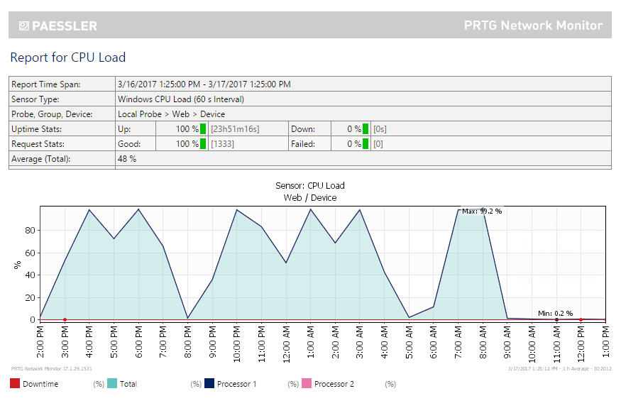

#### MemoryB:\SBA\apache-jmeter-3.1\bin\Rhino\17 Mar\Web\Memory.jpg

#### Network:B:\SBA\apache-jmeter-3.1\bin\Rhino\17 Mar\Web\Network.jpg

### Database Server:

#### CPU Load

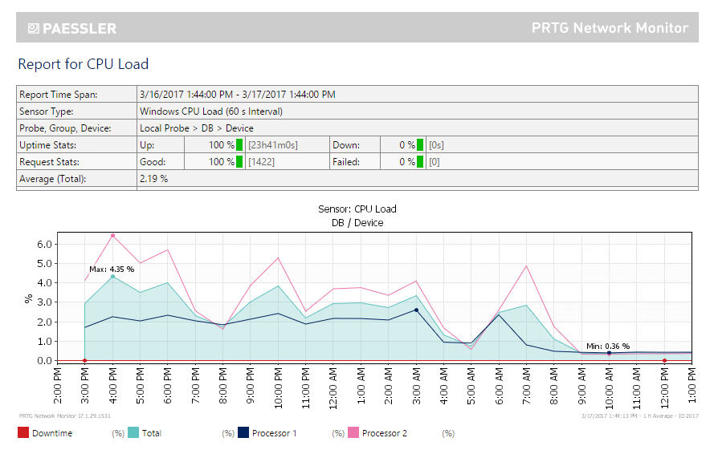

#### Memory

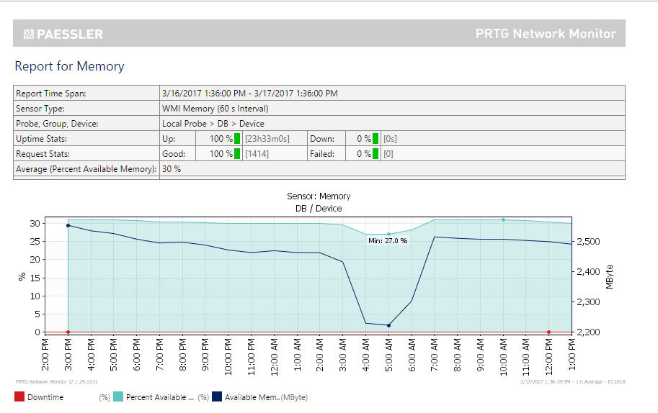

#### Network

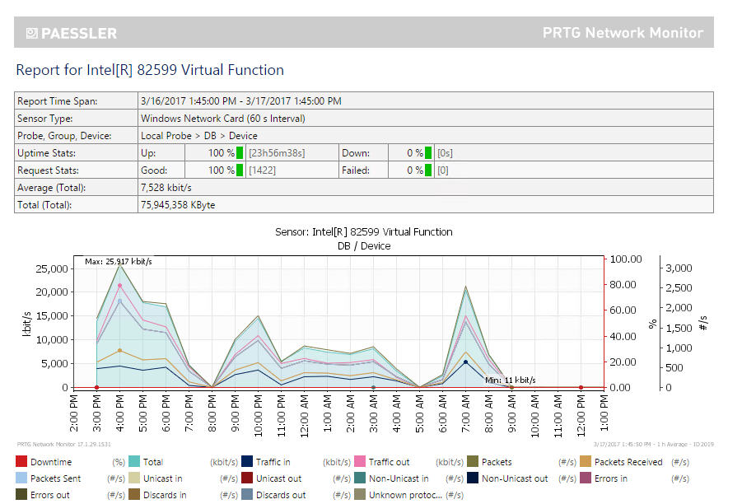

During executing time of these tests, after about 5 minutes, the CPU activity of Web Application Server was very high and many time raised alarms by PRTG Network Monitor tool.

Example – run 1:

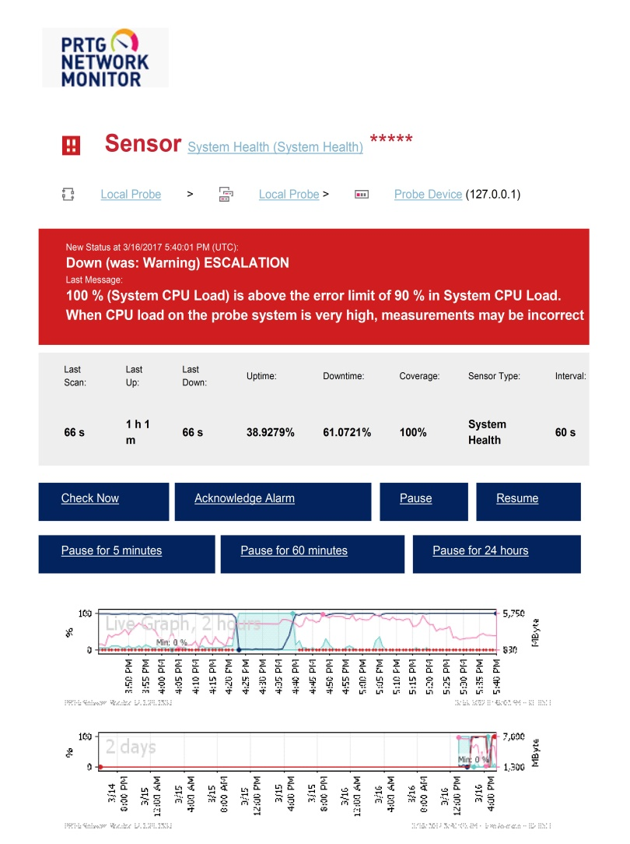

## Analysis Summary

All 6 Load Test rounds have been failed during Performance Test execution. All functions show many pages with response times that were much longer the expectation of 3s (or 10s for saving invoice). All requests to access a page or post/put data always have Slow Response Times.

The long response times appear to be because of system load.

A decision should be made to allocate more time for the fix to be developed and tested.